Activity 5.1 – Read & Reflect
Solidify your Understanding
Workbook

Why do we use explicit instruction?

Article Reading
- Martin, A.J. (2016). Using Load Reduction Instruction (LRI) to boost motivation and engagement. Leicester, UK: British Psychological Society.
  - Read the section titled “The cognitive architecture of the human mind: Working and long-term memory” on pp. 7-9
- Use the notetaking guide in the workbook to support your reading
Cognitive Parameters [meaning, parts of cognitive system involved in learning]
- The primary mechanisms for learning: ______________________ ___________________________

- Learning occurs when _______________________________________________________________
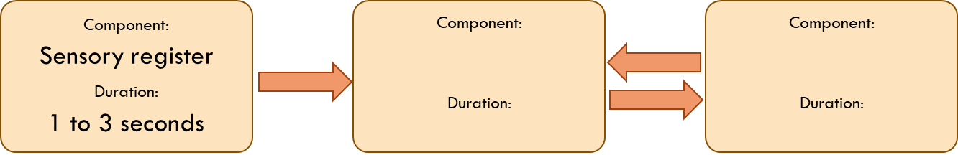

[Duration means the length of time something can be remembered]
- A major function of working memory is to ________________________________________________.
- From a cognitive load perspective, successful learning relies on building ____________________________ and efficiently managing __________________________________.

- The three goals for designing learning, suggested by cognitive load theorists, are to:
- ________________________________________________________ ,
- ________________________________________________________ , and
- _________________________________________________________

Reflect
- Students who need intensive intervention often have working memory difficulty. From Martin’s point of view, how should we design instruction to maximize learning for these students?

- Some educators focus on discovery learning, where groups of students are given complex real-world problems and work together to solve them with little guidance (Mayer, 2004)
  - Why might this present a challenge for students who need intensive intervention?

  - If a friend of yours was such an educator, what would you tell them about the needs of students who need intensive intervention?

